Name : Kanishk Patel
Section : D
RollNo. : 2115000505(26)

DBMS PRACTICAL ASSIGNMENT-2

Q1. Create the following tables and specify constraints at the time of the creation.

Table 1. Department.

- create table Department (Deptno number(3) primary key, Dname varchar2(20) unique, Location varchar2(20) Not null check(location in ('Delhi','Pune','Agra')));
- Desc Department;

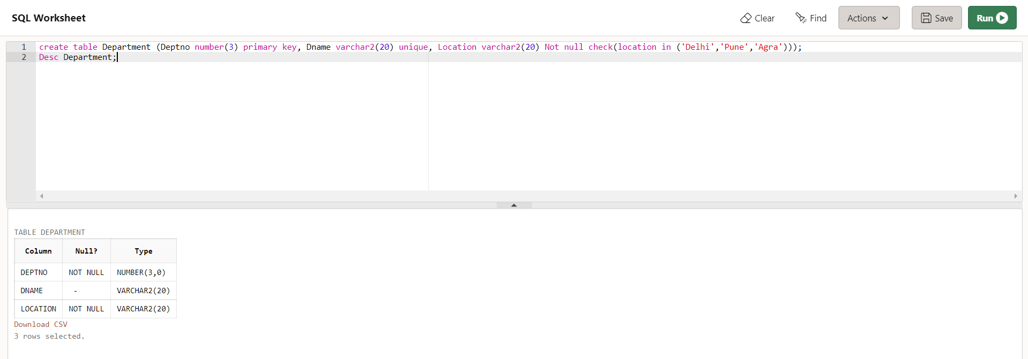

Table 2- Employee
- CREATE table Employee
- (Empno varchar2(5) primary key check(Empno like 'E%'),
- Ename varchar2(20) Unique,
- Designation varchar2(20) not null,
- Salary number(10) default 25000
- check(Salary between 15000 and 50000),
- Dob date not null,
- Dno number(3) references Department);
- desc Employee

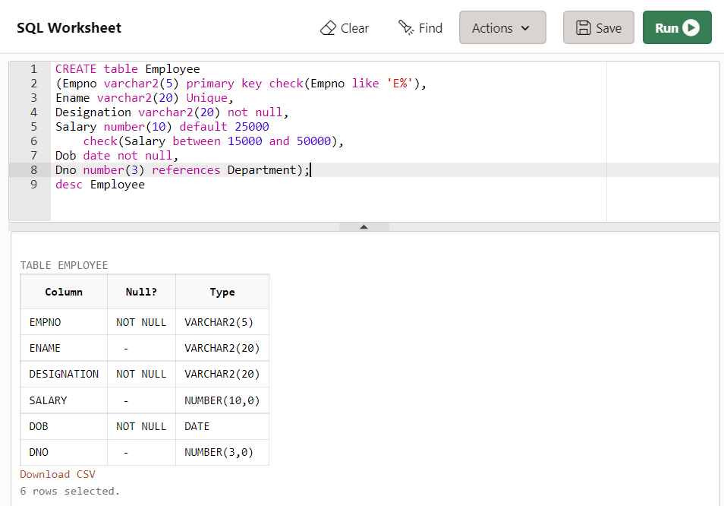

Table 3- Candidate

- CREATE table Candidate
- (Candidate_ID number(6) primary key,
- Candidate_name varchar2(20) Not null,
- Candidate_Email varchar2(30) Unique
- check(Candidate_Email like '%@%.%'),
- Candidate_Dept varchar2(2) default 'HR',
- Manager_ID integer references Candidate(Candidate_ID));
- desc Candidate;

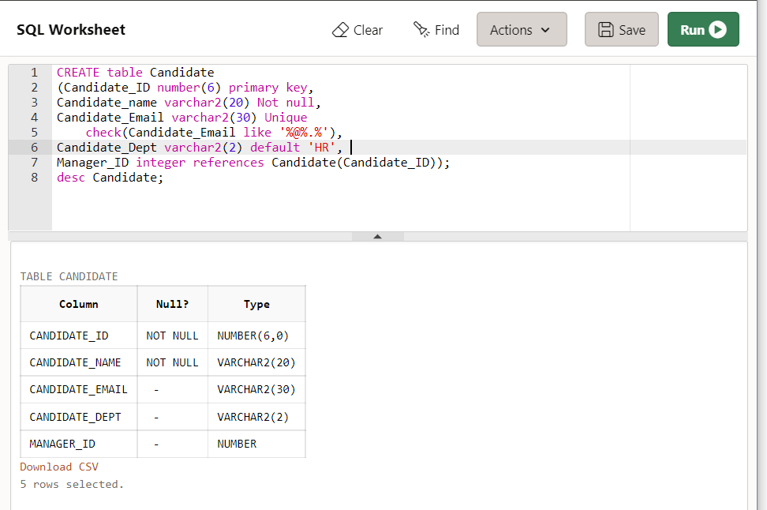

Q2- Create the schemas as specified above without specifying any constraints.

- CREATE TABLE College (cName varchar2(10), state varchar2(10), enrollment int);
- CREATE TABLE Student (sID int, sName varchar2(10), GPA number(2,1),sizeHS int);
- CREATE TABLE Apply (sID int, cName varchar2(10), major varchar2(20));
- DESC College;
- DESC Student;
- DESC Apply;

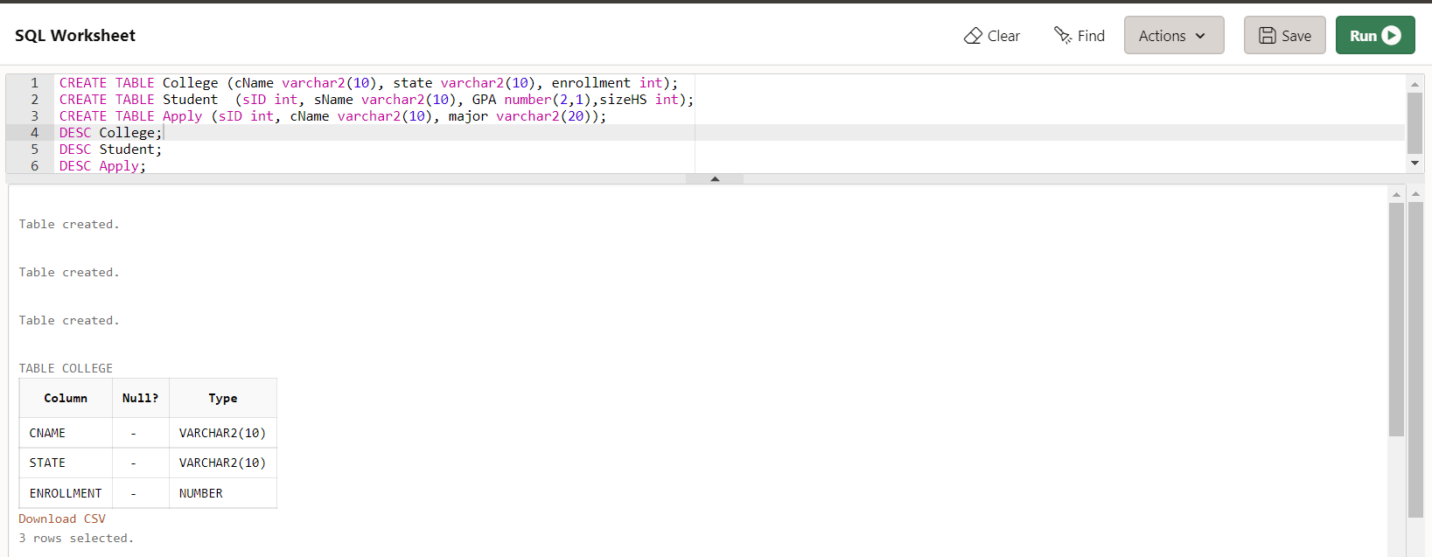
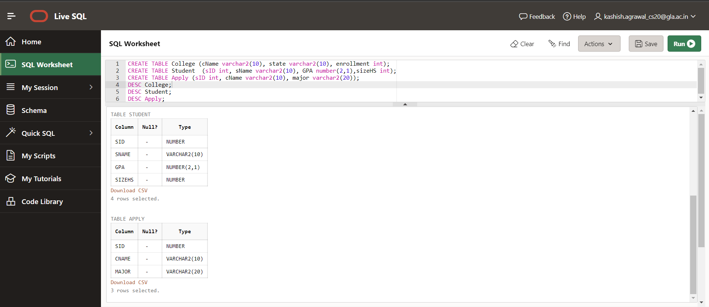

- alter table college add primary key(cName);
- alter table student Add primary key(sID);
- alter table apply Add primary key(sID,cName,major);
- alter table apply add Constraint fk_Student foreign key(sID) references Student;
- alter table apply modify(major varchar2(25));
- alter table apply add(decision varchar2(3) not null);
- alter table apply modify(decision char(1));
- alter table apply drop constraint fk_cName;
- alter table student drop column sizehs;
- alter table college drop primary key;
- alter table apply add constraint unique_apply unique(cName,major);
- alter table apply add constraint fk_apply foreign key(cName) references college on delete cascade;
- alter table apply add constraint fk_apply foreign key(sID) references student on delete set null;
- alter table college rename column enrollment to enroll;

